Hew Yi Wei’s Graphical Design Program

Introduction

Hello User!

My name is Hew Yi Wei (U2021893C) and this is my Mini-Project submission. It was quite a challenge programming this as turtle was entire new to everyone. Juggling all the other mods and this project was quite a challenge but I think I did alright. Initially I did a receive user input system from Idle but during class you mentioned not to do that, so I changed to text file and it was much easier and flexible.

Type of Patterns

With my code, you can create two types of patterns.

1. A wall of repeated shapes
   * Rows and columns of a desired shape
2. Concentric Shapes
   * Multiple different shapes circling the same origin
3. Shapes around origin
   * Multiple different shapes circling a point as close or as far from point
4. A Random Spew of Shapes
   * Random shapes and sizes of available primitives thrown on the display

Types of Shapes

My code consists of 3 main primitives. Circles, Polygons and Stars. Below are what parameters that can be customized.

Circles

* Radius
* Fill colour (only for pattern 1 and 3)
* Pen colour
* Angle of rotation (only for pattern 2)

Polygons

* Length
* Number of sides (only 3 and above)
* Fill colour (only for pattern 1 and 3)
* Pen colour
* Angle of rotation (only for pattern 2)

Stars

* Length
* Number of sides (only 5 and above)
* Fill colour (only for pattern 1 and 3)
* Pen colour
* Angle of rotation (only for pattern 2)

How to use my program

1. A wall of repeated shapes

Step 1: Open the **userInput.txt** found in the folder.

Step 2: On the first line, type **“RepPatt”**.

Step 3: On the next line, you can choose **“Circle”**, **“Polygon”** or **“Star”** followed by a space.

Step 4: On the same line, type in the radius of the circle if chosen. Type the length and

number of sides if polygon or star has been chosen separated with a space.

Step 5: On the same line, type the colours you want for the pen all separated by a space. Any unavailable colours will be automatically removed. The colours will be printed systematically. Alternatively, you can choose all the colours by just typing **“all”**.

Step 6: On the same line, first type “-“ (dash) to separate the pen and fill colours, then same as the previous step, type the colours you want for the pen all separated by a space. Any unavailable colours will be automatically removed. The colours will be printed systematically. Alternatively, you can choose all the colours by just typing **“all”**.

Step 7: Run the program!

It should look a little like this!

**[RepPatt]**

**Circle [Radius] [Pen Colour] – [Fill Colour]**

**[RepPatt]**

**Polygon [Length] [Number of Sides] [Pen Colour] – [Fill Colour]**

**[RepPatt]**

**Star [Length] [Number of Sides] [Pen Colour] – [Fill Colour]**

All without the square brackets.

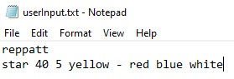

1. Concentric Shapes

Step 1: Open the **userInput.txt** found in the folder.

Step 2: On the first line, type **“ConPatt”**.

Step 3: On the next line, you can choose **“Circle”**, **“Polygon”** or **“Star”** followed by a space.

Step 4: On the same line, type in the radius of the circle if chosen. Type the length and

number of sides if polygon or star has been chosen separated with a space. With another space, type the angle of rotation and after 1 last space, type the pen colours you want separated by a space or type **“all”** for all colours.

Step 5: **Repeat Steps 3 and 4** to layer as much shapes as you want on different lines.

Step 6: Run the program!

It should look a little like this!

**[ConPatt]**

**[Circle] [Radius] [Angle of Rotation] [Pen Colour]**

**[Polygon] [Length] [Number of Sides] [Angle of Rotation] [Pen Colour]**

**[Star] [Length] [Number of Sides] [Angle of Rotation] [Pen Colour]**

All without the square brackets.

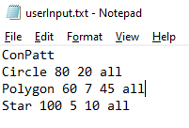

1. Shapes around origin

Step 1: Open the **userInput.txt** found in the folder.

Step 2: On the first line, type **“Around”**.

Step 3: On the next line, you can choose **“Circle”**, **“Polygon”** or **“Star”** followed by a space.

Step 4: On the same line, type in the radius of the circle if chosen. Type the length and

number of sides if polygon or star has been chosen separated with a space. With another space, type the number of shapes and after that, type the pen colours you want separated by a space or type **“all”** for all colours.

Step 5: On the same line, first type “-“ (dash) to separate the pen and fill colours, then same as the previous step, type the colours you want for the pen all separated by a space. Any unavailable colours will be automatically removed. The colours will be printed systematically. Alternatively, you can choose all the colours by just typing **“all”**.

Step 6: Run the program!

It should look a little like this!

**[Around]**

**[Circle] [Radius] [Number of Shapes] [Pen Colour] – [Fill Colour]**

**[Polygon] [Length] [Number of Sides] [Number of Shapes] [Pen Colour] – [Fill Colour]**

**[Star] [Length] [Number of Sides] [Number of Shapes] [Pen Colour] – [Fill Colour]**

All without the square brackets.

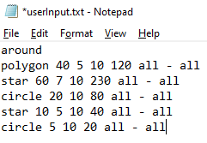

1. A Random Spew of Shapes

Step 1: Open the **userInput.txt** found in the folder.

Step 2: On the first line, type **“Random”**.

Step 3: Run the program!

Example 1

Input:

RepPatt

Star 40 5 all-all

Result:

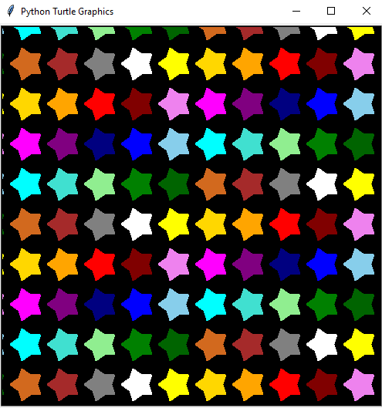

Example 2

Input:

ConPatt

Circle 50 10 all

Polygon 70 5 20 all

Result:

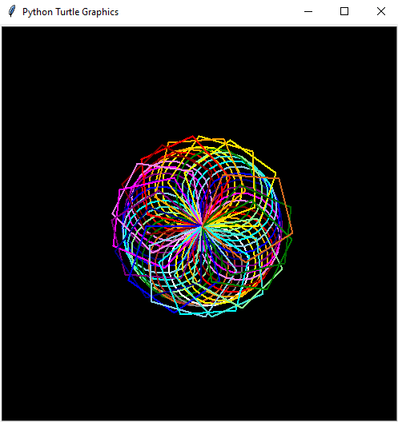

Example 3

Input:

around

circle 5 10 20 yellow - yellow

circle 10 10 40 yellow - yellow

circle 15 10 70 yellow - yellow

circle 20 10 120 yellow - yellow

circle 25 10 180 yellow – yellow

Result:

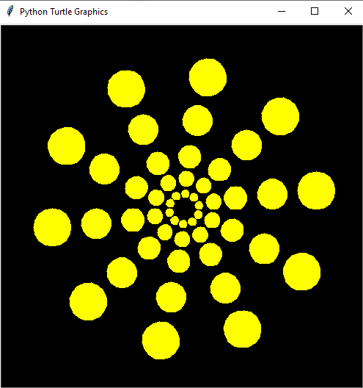

Example 4

Input:

Random

Result:

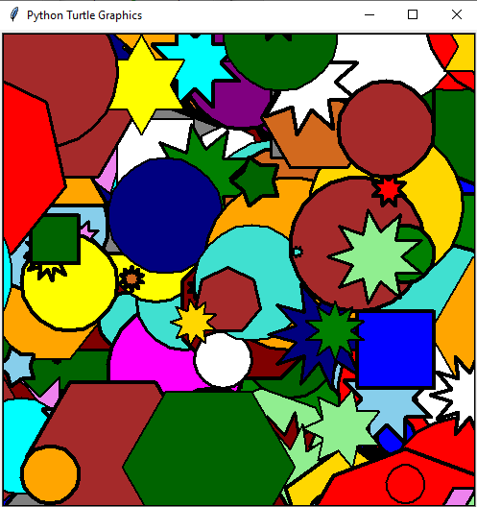

Strengths & Limitations

Strengths of my programs are the colours, the flexibility of number of sides for polygons and stars. For the colour scheme, unlimited number of colours can be chosen or “all” if the user chooses. The function would filter out unavailable colours and use the rest. If all are unusable, the function will prompt the user to try again. Next is the flexibility of the number of sides for polygons and stars. These two functions took me ages to figure out as the math behind it was quite confusing, but I managed. Polygons were easier but the stars were a huge headache as there are even and odd numbered sides which made things complicated.

Limitations of my program are the lack of primitive options, weird user interface, not very complex patterns. I have only got 3 different primitive options which is not a lot. My user interface might confuse users due to the different formatting. This is so because my “Wall of Patterns” allows pen and fill colours while my “Concentric Pattern” only allows pen colour as the fill colour will affect the “Concentric Pattern” results. My patterns are also not as complex as the examples given in the PDF.